Radiosurgery Assignment

**Genevieve Hayes | CISC 330 Assignment 4 | December 14, 2020**

The script **main_A4.m** will call all the functions for Assignment 4 which are located in the same folder. To run each question independently within main_A4.m, use the “Run Section” option while the cursor is placed in the desired section.

Table of Contents

Part 1 – Radiosurgery Modalities 1

Part 2 – Compute Dose Box 2

Part 3 – Draw 3D Radiosurgery Scene 2

Part 4 – Estimate Dose 2

Isocenter Dose Estimate (Underestimate) 2

OAR Dose Estimate (Overestimate) 3

Analysis 4

Check 4

Part 5 – Compute Dose Absorption Function Table 5

Part 6 – Compute Dose Absorption Function Table 5

Part 7 – Compute Beam Directions 6

Part 8 – Compute Skin Entry Points 6

Part 9 – Compute Beam Safety Flags 7

Part 10 – Compute Radial Distance 7

Part 11 – Compute Depth from Skin 7

Part 12 – Compute Point Dose from Beam 8

Part 13 – Compute Point Dose from All Beams 8

Part 14 – Compute Dose 8

Part 15 – Dosimetry Analysis 8

Part 16 – Compute Surface Dose 11

Appendix - Additional Functions 12

Method 12

Testing 12

References 13

# Part 1 – Radiosurgery Modalities

The most common types of radiosurgery modalities are Gamma Knife radioactive material-based systems and linear accelerator (LINAC) based systems. Currently there are no evidence-based differences in clinical outcomes using a Gamma Knife, a gantry-mounted LINAC or a CyberKnife [1]. The Gamma Knife system was specifically developed to treat tissue in the brain inaccessible to invasive surgery [1]. It is the most accurate method of brain radiosurgery and only requires a single treatment [2]. It is also the more invasive than LINAC-based systems because full head immobilization is required for accurate treatment [2].

LINAC-based radiotherapy systems are attractive because they are capable of dividing up treatments to better preserve adjacent tissue and have a lower initial cost than the Gamma Knife [3]. Another advantage of these systems is that they have the ability to treat tumours throughout the entire body [2]. The CyberKnife is a specific type of LINAC mounted on a robotic manipulator with an integrated image guidance system [1]. The advanced robotics of the CyberKnife can allow it to treat tumors in the body that move as a result of breathing with the same precision as treatments to rigid body parts [2]. Traditional gantry LINAC systems to not have this motion-correction ability but have a larger target area [4]. This larger target area also results in less than half the maximum dose than can be delivered by a CyberKnife [4].

The initial cost of purchasing a Gamma Knife is significantly high that a LINAC, however the LINAC systems require more costly maintenance due to their more complex design and have additional shielding requirements [1]. CyberKnife devices are more expensive than traditional gantry-mounted LINAC systems in initial cost and maintenance costs due to the additional robotic components of the CyberKnife [1].

|  |  |  |  |
| --- | --- | --- | --- |
|  | **Gamma Knife** | **CyberKnife** | **Gantry LINAC** |
| Uses | Brain surgery [5] | Brain and other radiosurgery [B] | Brain and other radiotherapy [3] |
| Source | 201 cobalt-60 sources [1] | Linear accelerator [6] | Linear accelerator |
| Beam Properties | 1.25 MeV Cobalt [1] | 6 MV photons [1] | 6 MV photons [1] |
| Radiologic accuracy | Better than 0.3 mm [5,6] | ~ 1.0 mm [6] | ~1.0 mm [4] |
| Patent positioning method | Rigid immobilization of skull with head frame for exact MRI and CT correlation from planning the 3D radiosurgical delivery [A]. | Non-rigid immobilization of the head using a thermoplastic face mask which is taped to the table during treatment for approximate MRI and CT correlation from planning the 3D the treatment [6]. | Rigid immobilization with head or body frame [3]. |
| Number of treatments per visit | One [6] | One or multiple [6] | One or multiple [5] |
| Motion correction | Some motion management is emerging for non-rigid patient fixations [7] | Yes [2] | No [2] |

# Part 2 – Compute Dose Box

See Compute_Dose_Box.m.

# Part 3 – Draw 3D Radiosurgery Scene

# Part 4 – Estimate Dose

An explanation of the dose estimation methods and illustrative sketches are presented below. The calculations were carried out in Matlab and can be seen in Part 4 of main_A4.m.

## Isocenter Dose Estimate (Underestimate)

This is designed to be an underestimate of the dose provided to the isocenter with all possible beams turned on.

* Calculate the number of possible beams with defined beam separation angle
* Calculate the distance between the head and the isocenter.
* Calculate the minimum possible skin depth to the isocenter using the smallest head axis, head_a. The minimum skin depth to the isocenter was found to be 115 mm.

* Use the Dose Absorption Table to estimate the dose per beam at the minimum isocenter skin depth, which at 115 mm was determined to be 0.80 units. All beams are centered on the isocenter therefore the radial dose will be at a maximum.
* Multiply the dose per beam by the number of beams.

The estimated minimum dose provided to the isocenter with all possible beams turned on is **29.6 units**.

## OAR Dose Estimate (Overestimate)

This is designed to be an overestimate of the dose provided to the OAR with all possible beams turned on. Based on the geometry of the problem and because the beams are all directed at the isocenter, it is expected that the maximum dose will occur at the point of the OAR closest to the PTV.

* Calculate the distance between the head and the OAR center.
* Calculate the distance between the OAR center and the isocenter.
* Calculate the angle between the furthest possible beams from the OAR center that still touch the OAR.

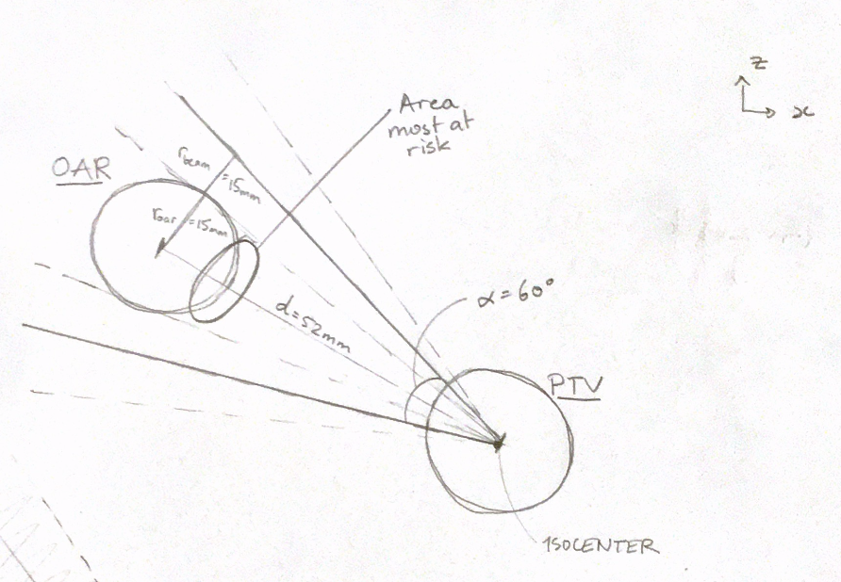

* Since the angle in 60 degrees, at least 2 beams could pass through the OAR in this plane. Since this is a 3-dimensional problem, there are an additional 2 beams that could pass through the OAR for a maximum possible number of 4 beams that could pass through the OAR.
* Calculate the maximum possible skin depth of the oar using the largest head axis, head_b. This point on the OAR is the closest point to the isocenter. The maximum skin depth within the OAR was found to be 159 mm.
* Calculate whether all 4 beams can be within a 7.5mm the radial distance of the OAR since that is the limit for it provide a full 1-unit dose.

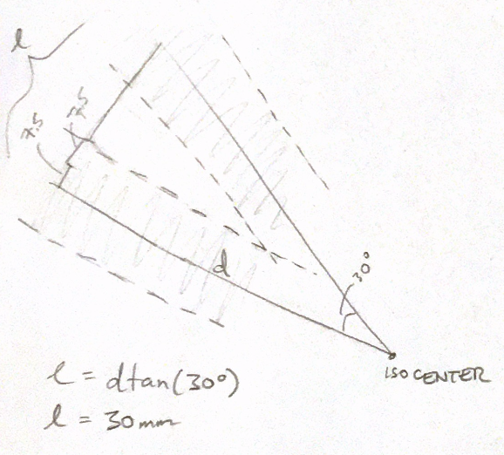

* Since it is possible for all 4 beam centers to be within 7.5mm of the OAR, the maximum dose per beam will depend only on the maximum skin depth.
* Use the Dose Absorption Table to estimate the dose per beam at the maximum OAR skin depth, which at 159 mm was determined to be 0.90 units.
* Multiply the dose per beam by the number of beams using the number of possible beams with defined beam separation angle calculated above.

The estimated maximum dose provided to the OAR with all possible beams turned on and all 4 possible beams passing through it is **3.6 units**.

## Analysis

The dose required in the ptv is D100 = 20 units and the maximum dose that can be applied to the OAR is Doarmax = 10 units. Therefore, these estimates would indicate that the treatment goals are realistic since in the “worst case scenarios” the PTV center is receiving 29.6 units which is more than the required D100 and the OAR is receiving 3.6 units which less than the maximum allowed Doarmax.

## Check

The functions built throughout the rest of this assignment determined (with all possible beams turned on) the isocenter dose to be 27.2 units and the maximum oar dose to be 0.9 units.

# Part 5 – Compute Dose Absorption Function Table

See Compute_Dose_Depth.m

# Part 6 – Compute Dose Absorption Function Table

See Compute_Radial_Dose.m

# Part 7 – Compute Beam Directions

See Compute_Beam_Directions.m.

**37 beams** were calculated with 30-degree separation angles.

The latitudes and longitudes for each beam were calculated using:

$$latitude=atan2(v_{z}, \sqrt{v_{x}^{2}+v_{y}^{2}})$$

$$longitude=atan2(v_{y},v_{x})$$

# Part 8 – Compute Skin Entry Points

See Compute_Skin_Entry_Points.m. This function also computes the skin depth between each skin entry point and the isocenter. ~7-8 second run time.

# Part 9 – Compute Beam Safety Flags

See Compute_Beam_Safety_Flags.m. ~7-8 second run time.

The safety flags were determined using the function numIntersectionsOfSphereAndCylinder(C,R,r,P,v) from Assignment 1 which can be seen in the Appendix. The beams are treated like 30mm-diameter cylinders and any that intersect with the OAR sphere are flagged as unsafe.

**4 beams** were deemed unsafe because they intersect with the OAR.

# Part 10 – Compute Radial Distance

See Compute_Radial_Distance.m.

Test: Test the ground truth case of the top helmet beam (90-degree latitude) with the point-of-interest at the lateral edge of the PTV. The result is radial_distance = 15 mm, the radius of the PTV as expected.

# Part 11 – Compute Depth from Skin

See Compute_Depth_from_Skin.m.

Test: Test the ground truth case of the top helmet beam (90-degree latitude) with the point-of-interest at the lateral edge of the PTV. The result is depth_from_skin = 60 mm. The skin entry point is approximately [30, 0, 75] and the isocenter [30, 0, 15], therefore a skin depth of 60 mm is expected.

# Part 12 – Compute Point Dose from Beam

See Compute_Point_Dose_from_Beam.m.

Test: Test the case of the point-of-interest being the isocenter which is ~60mm from the skin. Visually estimating the depth dose from the Depth Absorption Dose Image, the dose at a depth of 60mm is expected to be ~0.80mm. The result from the calculation is a dose of 0.8040 (0.8040 from depth and 1 from radial) as expected.

# Part 13 – Compute Point Dose from All Beams

See Compute_Point_Dose_from_All_Beams.m

Test: Testing with all safe beams (34 beams) with the point-of-interest as the isocenter which results in a dose of 24.43 units. The function was tested with all beams (37 beams) with the point-of-interest as the isocenter which results in a dose of 27.21 units. This only slightly below the dose estimated in Part 4. Finally, the function was tested with all beams (37 beams) with the point-of-interest as the edge of the OAR closest to the PTV which results in a dose of 0.86 which is slightly below the dose estimated in Part 4.

# Part 14 – Compute Dose

See Compute_Dose.m. This function was tested on the full dose box with a voxel size of 10mm. The maximum dose calculated was 24.35 units.

# Part 15 – Dosimetry Analysis

Dose boxes were built around the PTV and OAR respectively, then using a voxel size of 1 mm, the dose from all beams with the volume of the cubes was calculated. The computing time for the OAR dose calculation is ~167 seconds and the PTV dose calculation is ~170 seconds. Dose volume histograms were generated for the PTV and the OAR respectively.

The treatment plan was optimized by increasing D0 by a **factor of 7.5** so that 100% of the PTV volume gets the required D100 = 20 units while none of the OAT gets more than the maximum DOARMAX = 10 units. The minimum dose that was calculated inside the PTV volume was 2.70 units which requires an increase by 7.5 to reach the require D100. The Dose Volume Histogram (DVH) for scaling factors of 3, 4 and 5 are illustrated below which show how the histogram moves with scaling. Following it is the optimized DVH scaled by 7.5.

It should be noted no OAR points get above the maximum DOARMAX in both the non-optimized and optimized cases.

# Part 16 – Compute Surface Dose

See Compute_Surface_Dose.m.

# Appendix - Additional Functions

Number of Intersections between Sphere and Cylinder (Assignment 1, Part 4)

function numInt = numIntersectionsOfSphereAndCylinder(C,R,r,P,v)

## Method

* Create a unit vector perpendicular to v, the direction vector of the cylinder by solving $v_{x}∙1+ v_{y}∙1+v_{z}∙v_{2z} =0$. Then $v_{2}=\frac{\left[1,1,v_{2z}\right]}{norm\left(v_{2}\right)}$
  + Create $v_{3}$, V and P such that:

$$v_{3}=v_{2}×v_{1}$$

$$V=\left[\begin{matrix}-v_{1} \\ v_{2} \\ v_{3}\end{matrix}\right]$$

$$P=\left[\begin{matrix}P_{1x}-P_{2x} \\ P_{1y}-P_{2y} \\ P_{1z}-P_{2z}\end{matrix}\right]$$

Using the formula of a line $L=P+tV$, determine t of closest intersection by

$$t_{int}=V^{-1}×P$$

Then compute the location on the line of closest intersection of the line with the sphere center, $L_{1}=P_{1}+t_{int}V_{1}$.

Compute the distance $d={abs(L}_{1}-C)$.

Compute the value $val=\left\|d\right\|-R-r$. If val < 0 then there are “2” intersections between the cylinder and the sphere, i.e. the cylinder enters and exits the sphere at different locations. If val = 0 then there is exactly 1 intersection between the cylinder and the sphere. If val > 0, then there are no intersections between the cylinder and the sphere.

## Testing

* Test 1: Case of zero intersections between sphere and cylinder. The function return numInt = 0.
* Test 2: Case of single point intersection between sphere and cylinder. Sphere is the unit vector centered at the origin, the cylinder has radius 1 centered at [2,0,0] and extends in the y-direction. The function return numInt = 1.
* Test 3: Case where cylinder enters and exits the sphere at different locations. In this case the function return numInt = 2.

# References

[1] V. W. Stieber, J. D. Bourland, W. A. Tomé, and M. P. Mehta, “Gentlemen (and Ladies), Choose your Weapons: Gamma Knife vs. Linear Accelerator Radiosurgery,” *Technol Cancer Res Treat*, vol. 2, no. 2, pp. 79–85, Apr. 2003, doi: [10.1177/153303460300200202](https://doi.org/10.1177/153303460300200202).

[2] “Phoenix Radiotherapy | CyberKnife Vs Gamma Knife,” *Phoenix CyberKnife Radiation & Oncology Center*. <https://www.phoenixcyberknifecenter.com/cyberknife-vs-gamma-knife/> (accessed Dec. 14, 2020).

[3] “Radiosurgery Treatment Comparison.” <http://www.mygenesishealth.com/treatment-options/genesis-cyberknife/treatment-comparison.html> (accessed Dec. 14, 2020).

[4] C. Ding, “Dosimetric comparison of SBRT for lung cancer: Cyberknife vs. Linac,” p. 26.

[5] “Comparison Gamma Knife to CyberKnife,” *Neurosurgery*. <https://med.virginia.edu/neurosurgery/services/gamma-knife/for-physicians/comparison-gamma-knife-to-cyberknife/> (accessed Dec. 14, 2020).

[6] R. M. G. K. Center, “Comparison of Gamma Knife to Linear Accelerator or Cyberknife.” <https://www.rmgk.com/gamma-knife-vs-linac> (accessed Dec. 14, 2020).

[7] E. W. Team, “Canada Access Request,” *Elekta AB*. <https://www.elekta.com/meta/canadaAccessRequest/> (accessed Dec. 14, 2020).